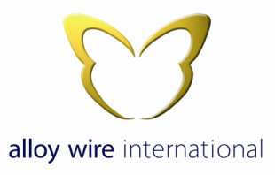
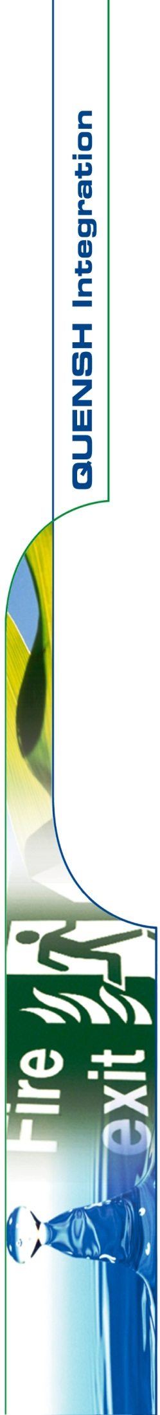

ENVIROMENTAL POLICY STATEMENT

Management of Alloy Wire International regards the promotion and preservation of the environment as a mutual objective for Management and employees at all levels.

We are fully committed to protecting and continually improving the quality of our working and local environments. We are committed to working pro-actively with, and communicating this policy to our employees, clients, contractors and all other external parties to achieve a safer, cleaner, healthier and sustainable environment. This will fulfil present and future human and legislative needs.

The objectives of this policy are to:

- Reduce the production of waste and encourage wherever possible it’s re-use or re-cycling.
- Encourage greater staff involvement through environmental awareness training, the understanding of environmental issues and continual environmental improvements.
- Encourage staff to become more efficient and sustainable in their use and the preservation of energy.
- Evaluate environmental impacts when considering new products, plant, equipment, buildings and processes.
- Prevent pollution and nuisance.
- Manage the correct, safe and effective disposal of waste materials and products through approved and qualified agencies/providers and wherever possible minimise wastes to landfill.
- Maintain company premises, production processes and surrounding areas in a clean and tidy condition to ensure minimum impact on our customers and neighbours.

Alloy Wire International will comply with environmental laws, regulations and other requirements relevant to our business. We will provide adequate resources and closely monitor our administration, production, packing and despatch processes to ensure that the company’s operations and opportunities are effectively managed and risks mitigated in accordance with the requirements of BS EN 9100, BS EN ISO 9001, BS EN ISO 14001 & BS EN ISO 45001.

This policy will be communicated to all staff and any necessary stakeholders and interested parties i.e. sub-contractors that may be working on our behalf, and will be available to the public via Alloy Wire International web site: www.alloywire.com

The Directors will review this policy and formulate QUENSH objectives during annual management reviews to ensure its integrity, effectiveness and compatibility with the context and strategic direction of the organisation.

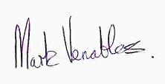
Signed:

Mark Venables
Managing Director
1st August 2017.

